
godiz ag

(practise) IPA 2026
Cost control components

Josiah Spilker
godiz ag
Industriestrasse 31
8305 Dietlikon

Contents
Part 1 4
1.1 Foreword 5
1.2 Project Organization 6
1.3 Task Description 7
1.4 Time Schedule 8
1.3.1 Actual/Expected comparison 9
1.5 Work Journal 13
1.5.1 Monday, 16.02.2026 13
1.5.2 Tuesday, 17.02.26 14
1.5.3 Wednesday, 18.02.26 15
1.5.4 Thursday, 19.02.26 16
1.5.5 Friday, 20.02.26 17
1.5.6 Monday, 23.02.26 18
1.5.7 Tuesday, 24.02.26 19
1.5.8 Wednesday, 25.02.26 20
1.6 Personal Conclusion 21
Part 2 22
2.0 Introduction 23
2 Inform 24
2.1 Initial situation 24
2.2 Objective 24
2.3 Non-Functional Requirements 24
2.4 Functional Requirements 25
2.5 Technical Specifications 26
2.6 Questions 26
3 Plan 27
3.1 Gantt Chart 27
3.2 ERM Model 28
3.3 Test Plan/Cases 29
3.4 UML Diagrams 30
4 Decide 31
4.1 Architecture & Design Decisions 31
4.2 Column Strategy 31
4.3 Visual Indicators 32
4.4 Reporting Format 32
4.5 Date decisions 33
4.6 Deactivation of Budget 33
5 Realise 34
5.1 Creation of Dataverse entities 34
5.2 Calculated/Rollup Field Configuration 35
5.3 Flows 36
5.3.1 Warning flow 37
5.3.2 Deactivate expired budgets flow 39
5.3.3 Weekly Cost Overview flow 40
5.4 Questions 41
6 Control 42
6.1 Test Protocol 42
6.2 Test Case T-08 44
6.3 Test Case T-12 45
6.3 Boundary Testing 46
6.4 Concurrency Scenario 48
7 Evaluate 49
7.1 Reflection 50
7.2 IPERKA concerns 51
7.3 Possible Future Improvement 52
7.4 Summary 53
8 Appendix 54
8.1 Glossary 54
8.2 Bibliography 56
8.3 Declaration of Independent Work 56

Part 1

1.1 Foreword

This documentation is part of the IPA of Josiah Spilker, conducted at godiz ag in Dietlikon. It describes the workflow and methodology behind the development of a cost control component for the internal Microsoft Dynamics 365 CRM system.
The documentation is divided into two parts:
Part 1 outlines the detailed task description and the project schedule. It specifies the resources used and prior knowledge required for the project.
Part 2 shows the documentation of the implementation. It describes the realization of the solution, the challenges encountered during development, and the testing procedures applied.
The entire project was completed using the IPERKA project management methodology. This methodology was chosen due to it being required in Task description in the document ProbeIPAAufgabenstellung.pdf. My personal reflection and conclusion are provided at the end of the report.
While all Microsoft Documents were saved with version control throughout I was informed on Friday, 20.02.26 about the importance of version control and set up a git repository for all relevant documents which can be found here: Josiah-Spilker/Probe-IPA
You may have to ask for permission as the Repo. is private.

1.2 Project Organization

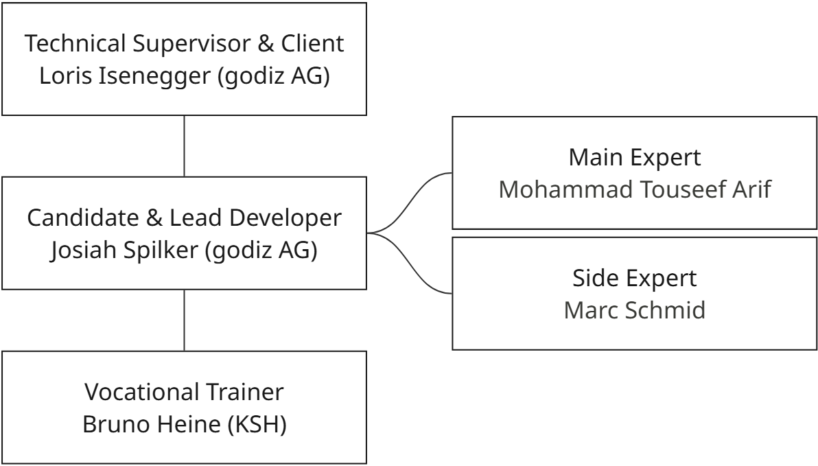

The following roles are involved in this IPA project:

Training company and location:
godiz ag
Industriestrasse 31
8305 Dietlikon

Candidate:
Josiah Spilker
siahspilker@gmail.com
078 672 29 33

Vocational trainer/training company:
Heine Bruno
Kantonsschule Hottingen
Minervastrasse 14, 8032 Zürich
079 329 06 23
bruno.heine@ksh.ch

Responsible Specialist:
Isenegger Loris
godiz ag
+41 79 260 91 36
loris.isenegger@godiz.com

Main Expert:
Arif Mohammad Touseef
079 903 42 41
arif.touseef@protonmail.com

Side Expert:
Schmid Marc
+41 79 780 20 44
faetzminator@gmail.com

1.3 Task Description

The primary objective of this (practise) IPA is to design and implement a Cost Control Component within the CRM system at godiz ag. Currently, the company lacks a solution for tracking operational costs and budgets, relying instead on manual methods that lead to a lack of transparency regarding budget consumption. The purpose of this project is to fix this issue by creating a system which records expenses and the configuration of specific budgets while monitoring budgets.
The core of the assignment involves designing a series of data flows and model driven app modifications within the existing Dataverse environment. This requires the creation of two main custom entities. A Budget entity will define the financial constraints, including fields for the validity period, total amount, category, and the responsible owner. An Expense entity will capture individual transactions, including the description, amount, date, and a link to the corresponding budget. These entities must be connected via a one-to-many relationship.
The highest priority is the implementation of a warning system that triggers automatically when a budget exceeds a defined threshold, in my case eighty percent, and sends a notification to the responsible manager. A secondary workflow is required to manage the lifecycle of budget records by automatically setting them to an inactive status once their validity period has expired. Optional features include a scheduled weekly flow to generate cost summaries for management and visual indicators, such as a traffic light system, to display the status of a budget directly on the user interface. The entire solution must be built as a Model Driven App and be exportable as a managed solution to ensure it can be easily deployed to new environments.

1.4 Time Schedule
The project schedule follows the project planning method IPERKA (Inform, Plan, Decide, Realise, Control, Evaluate). The total duration of this project is 10 days or 80 hours It started on February 16, 2026, and officially ended on February 27, 2026.
I chose to give myself half an hour or more of leeway on most days throughout this project to give myself a daily buffer. This helps keep me on track without creating unnecessary stress regarding deadlines. While working I also noticed that many tasks do not take as long as estimated, giving me even more buffer-time for larger, more complex tasks.
To have precise tracking and to fulfill requirements, I broke the project down into work packages of 2 hours. I decided to plan and log my time in the same document, the Gantt chart, which I heavily modified from a template. My idea was that I would be able to easily see the difference between my current state and where I would need to be to stay on track.
This worked quite well for the most part. I logged my efforts throughout the day in the Gantt chart as well as in Harvest, comparing them at the end of the day and correcting where necessary.
The time schedules both planned and actual contain imprecise and precise time planning in their respective documents. These are denoted by the colored rows found throughout the table at the same position as their corresponding task.

1.3.1 Actual/Expected comparison

As for the timelines actual schedule compared to its planned one, I overshot it by a couple of days. While planning, I knew I was giving myself a lot of leeway with the estimates I made for tasks. However, I didn’t expect to be finished with my project so ahead of schedule. While planning, I considered setting an early end for myself but decided not to although the estimates would have been more accurate. I simply wanted a schedule that, if followed, would guarantee a completed project.
Although I gave 15 hours to the documentation step which I utilized throughout the project this was intended for general, otherwise unassigned documentation that didn’t belong to a specific IPERKA task. In retrospect, this was one of the few areas I underestimated in my Gantt chart, and it is a major reason for the difference between the actual and expected hours. I realize now that I should have planned significantly more hours for the final report compilation rather than just specific task-based documentation.
Another point I would like to highlight is the difference between what I planned and what I actually worked on. Take Rows 40 - 43 as an example, specifically T4.7 Final checks / Export Managed Solution and T4.8 Export Managed Solution / Implement Visuals. These tasks diverged significantly in reality. some were unplanned new tasks, while others, like the visuals, were implemented earlier during other steps or merged. This is something I aim to avoid next time by planning my work more carefully and being more careful in my informing phase.

Task Deviation Chart
Task | Estimate (Hours) | Total (Hours) | Deviation (Hours) | Justification
T0 : Documentation | 15.00 h | 18.25 h | + 3.25 h | Underestimated effort for final report compilation, formatting, and Gantt chart integration.
T1 : Inform | 4.75 h | 3.25 h | - 1.50 h | Information gathering was more efficient than anticipated due to prior knowledge.
T2 : Plan | 11.00 h | 7.50 h | - 3.50 h | Planning was completed faster than scheduled; standard templates accelerated the process.
T3 : Decide | 1.00 h | 0.50 h | - 0.50 h | Decision-making was straightforward with no major architectural conflicts.
T4 : Realise | 22.00 h | 10.75 h | - 11.25 h | Slight deviation. The "Low-Code" nature of Dataverse allowed for extremely rapid implementation of entities and flows
T5 : Control | 10.00 h | 4.50 h | - 5.50 h | Testing proceeded quickly as no major bugs required extensive reworking.
T6 : Evaluate | 8.00 h | 6.50 h | - 1.50 h | Evaluation was completed within the scheduled timeframe.
Total | 71.75 h | 51.25 h | - 20.50 h | Project completed significantly before schedule.

1.5 Work Journal

1.5.1 Monday, 16.02.2026
Activities | Set up the documentation structure Create an initial schedule. I also Wrote the first part of the documentation. I Studied the task description and criteria catalogue, as well as part of the Dynamics CRM setup. The largest use of time however was the creation of my Gantt.
Achieved Goals | Created the base for the Documentation.  Created and filled out my Gantt chart.  Familiarized myself with my Task and work environment.
Problems | Fire Alarm interrupted my work, lasting only 15 minutes. Specialist not available for help today.
Assistance | Used Gemini throughout the day for suggestions on Document formatting and correction of all of my Text.  Used Gantt template found Online
Unplanned Work | -
Reflection | I was able to start my IPA well, and the first day went smoothly. Creating the schedule/ Gantt and planning took more time than expected.  I was able to complete the first part of the documentation. Designing the Gantt chart was quite enjoyable.

1.5.2 Tuesday, 17.02.26
Activities | I started my day by finishing my review of the dynamics setup and informing myself on what might be needed. I managed to finish my ERM Model relatively quickly and documented the process. I also managed to conceive and plan all relevant test cases. Also worked on the Gantt because of formatting issues
Achieved Goals | Finished Setup review. Grasped full structure of Task. Moved on to T2: Plan and completed the ERM Model as well as All Test Cases.
Problems | Was intermittently interrupted by Issues regarding Vzug and a not so smooth knowledge transfer from the week before.
Assistance | Asked for some Templates regarding IPA formatting.  Cleared up some unclear tasks.  Used Gemini for Text correction
Unplanned Work | -
Reflection | Today was very productive. I was able to finish everything I had planned and more. I am now more than half a day ahead of schedule and I am finding this type of project work to be much more enjoyable than my previous project.

1.5.3 Wednesday, 18.02.26
Activities | Today I was able to start working in Dynamics, managing to almost fully create the necessary Dataverse entities and their business logic. Before that, I finished the test cases and UML diagrams and made the final design decisions.
Achieved Goals | I completed T2 and T3 (Plan and Decide), as well as T4.1, and made significant progress on T4.2 with the Dataverse tables and their logic. I encountered a roadblock in the business logic I had planned for the budget status, as calculated fields cannot be used in certain ordering/comparison operations.
Problems | Found a Roadblock in the Business logic I had planned for the budget status where you can’t order by calculated fields.
Assistance | Used Gemini for Text correction
Unplanned Work | -
Reflection | Overall, today went rather well. I am not entirely thrilled to be working exclusively on the Dataverse tables at this stage (I’m getting tired of databases), but it is worth it to get to the app and cloud flows. My time estimates for the Realise steps also seem more accurate than those for Inform, Plan, and Decide I attribute this to having continuously estimated real implementation work rather than planning tasks.

1.5.4 Thursday, 19.02.26
Activities | Today I was able to start on the logic for the budget status code and the tables fields in forms and views. I also created the warning flow
Achieved Goals | I wasn’t able to complete anything in its entirety due to only 2 hours of feasible work time
Problems | I woke up with a migraine today, leading to a very short workday from 15-17. The calculations for budget status code were also more difficult than planned and required a different course of action
Assistance | Used Gemini for Text correction and help on conceiving new calculation possibilities
Unplanned Work | -
Reflection | To be honest, I’m not very happy with how today went, not only because of the short working hours I found myself confined to. But also, the fact that I couldn’t complete anything fully, only partly finishing or arriving at roadblocks.

1.5.5 Friday, 20.02.26
Activities | Worked on implementation of realisation tasks 4.1-4.5. that being both tables, 2 flows and the modeldriven app and its business logic.  Also started on weekly cost overview flow, though got caught up in formatting it.
Achieved Goals | Finished multiple tasks in the realisation step as described in activities
Problems | -
Assistance | Gemini used for text correction and help on formatting the data for the budget overview.  Received valuable feedback from the “experts” that visited me throughout the day
Unplanned Work | -
Reflection | Today went great, especially compared to yesterday. Being able to complete so many tasks in one day was a welcome surprise. I also greatly appreciated the comments I got from loris and David, helping me with Issues I didn’t even know I had.

1.5.6 Monday, 23.02.26
Activities | Worked on weekly cost overview, made sure everything was in order for the upcoming export step, worked for multiple hours on the documentation of the realisation step.
Achieved Goals | Completed the cost overview flow with mail formatting and all. Was able to essentialy finish with the realisation chapter aside from the last step
Problems | Arrived at work around 20 minutes late due to a bus cancellation.
Assistance | Gemini used for general text correction and continued to help on formatting the data for the budget overview.
Unplanned Work | -
Reflection | Today went quite well, while I didn’t get much done in terms of completing tasks, I did find a lot of time for documenting what I had completed. That being said, I had a great sense of accomplishment to know that the development step was completed. Arriving late also had little impact as I am least effective in the first hour of the day in my opinion.

1.5.7 Tuesday, 24.02.26
Activities | Today I worked further on exporting the solution successfully. I also worked on every task within the control chapter documenting as I went. I was able to start on my reflection and started finalizing the documentation.
Achieved Goals | I was able to successfully export the managed solution. After which I completed every aspect of the control chapter. For the evaluation I was able to start the last chapter.
Problems | New unplanned tests needed to be created.
Assistance | Gemini for Text correction.
Unplanned Work | -
Reflection | Today went well. I was able to fly through the control section, given the projects small scope and minimal testing requirements. I did have to create all new tests for components I had not planned for at the time. I also got hung up on the export because of an “error”.

1.5.8 Wednesday, 25.02.26
Activities | Focused almost exclusively on finalizing the documentation. I also modified the Gantt chart to include the Target vs. Actual comparison.
Achieved Goals | I successfully completed the project and am ready to submit the project. Specifically, I finalized the Reflection, the main Report, the Target vs. Actual analysis, and the handover.
Problems | I cannot submit a finished Gantt chart before the project is over, yet the project cannot be marked complete until the Gantt chart is finished.
Assistance | Used Gemini for text correction and formatting suggestions regarding chapter placement
Unplanned Work | -
Reflection | Today was very satisfying. Having the finish line in sight provided more than enough motivation to spend the entire day typing and formatting

1.6 Personal Conclusion
In retrospect, I am very happy with how this project turned out. I successfully turned the functional requirements into a working solution, effectively applying the skills I have acquired since joining godiz ag. The realization phase was particularly engaging. I could see real results from my efforts aside from a page and word counter going up in a word doc. My favorite part of the IPA however was the creation of my Gantt chart which I take great pride in.
A primary challenge was resource availability. With my technical supervisor Loris frequently occupied in meetings or absent, I faced moments where requirements were unclear. This had the effect of forcing me to make decisions regarding the project on my own without immediately knowing if they were correct. This shouldn’t be a problem in the future though. Additionally, a health issue (migraine) on Thursday shortened my working hours which caused some stress, as my buffer time had been used up in a day. I had so much of it though, that it didn’t make as big a difference as it could have.
Technically, I was able to learn a lot from this project, tackling new parts of Dynamics that I hadn’t interacted with prior to this project. For example, the entire logic behind calculated and rollup fields was new to me and brought all new insights into what Dynamics is capable of. From a process perspective, I learned that documentation and planning are not just administrative overhead but are critical for maintaining focus when development gets complex.
For future projects, specifically the final IPA, I intend on adjusting my planning strategy. I want to keep tasks obviously separate with as little overlap as possible and not make my Gantt quite so big involving less extra features. My time estimates were overly generous having too much leeway, which made the schedule look inaccurate. I want tighter, more realistic estimates. Lastly, I want to keep communication as open as possible. This time around having nobody I could ask questions on day 1 was not ideal. I intent to make sure this is not the case for the real IPA.

Part 2

2.0 Introduction

For the duration of this project, I used the IPERKA methodology which translates from German to (Inform, Plan, Decide, Realise, Control, Evaluate). This model served as both the structure of this documentation and ensured clear progression from the first phase of informing to the final product and evaluation.
However, the practical application and use of this methodology revealed certain limitations regarding flexibility. This model follows a strict Waterfall approach, assuming that one phase is entirely completed before the next begins. In my experience, the development process was more fluid and iterative. For instance, the Inform and Plan phases overlapped, at least at the start. The Gantt chart / time planner while part of the planning phase was worked on while I was still analysing the task requirements, because to know how long one needs to inform oneself, you must first plan for the informing. Unforeseen technical constraints found during the Realise phase occasionally also required revisiting findings made in the Plan phase. Especially during the creation of the Dataverse entities which would be changed on multiple occasions to better suite the tasks at hand.
Despite these rigidities, the methodology provided a necessary framework for maintaining a clear overview of the project. The following chapters document the project execution according to this structure, while acknowledging that the actual workflow deviated from it on multiple occasions.

2 Inform

2.1 Initial situation
godiz ag uses Microsoft Dynamics 365 CRM. However, there is currently no integrated solution for tracking costs and budgets within the system. Budgets in the current system are created manually and are not enforced by anything other than the users who create and manage them, leading to a lack of clarity regarding current budget consumption. To fix this issue, there is a plan to implement automated controls within Dynamics. These measures will replace manual tracking with a system that actively monitors budgets, ensures their validity, and visualizes them using a color coded schema.

2.2 Objective
The primary objective of this project is to develop a custom Cost Control Component integrated into the existing Dynamics 365 environment. This solution will allow users to record expenses and link them to defined budgets.
The system must provide real time insights into financial status using visual indicators, traffic light system, and automate administrative tasks such as budget monitoring and archiving. The solution must be user friendly and deployed as a Managed Solution.

2.3 Non-Functional Requirements
- Usability: The user interface must be intuitive and follow guidelines set by godiz ag and Microsoft.
- Reliability: The background flows must handle errors gracefully without crashing the page.
- Deployment: The final product must be exportable as a Managed Solution.

2.4 Functional Requirements
Based on the task descriptions, the following functions had to be implemented:

Data Management:
  - Creation of a Budget entity with custom fields such as amount, valid dates, warning thresholds etc.
  - Creation of an Expense entity which would have a 1 to n relationship with budget where 1 budget would be assigned many expenses which would contain fields like category, cost, Managed/Issues by etc.

Business Logic & Calculation:
  - There would be 3 final fields which needed calculating, all finding themselves in the budget table. The first of which being the warning threshold which I set to simply be 80% of a max value set by the owner. Another would be a rollup field taking the sum of all related expenses and storing that as the current consumption. The last would be the status code of the budget: being ok, critical or exceeded if the budget had been overstepped.
  - The status code of the budget was planned to be a calculated text field, simply making if statements based of the other 2 calculated fields.

Automation:
  - 3 total flows would need to be implemented into this project, the first of which being a warning flow which would send a warning email to the responsible owner of the budget when a threshold was surpassed.
  - The second flow would automatically close all expired budgets whose valid to date was past.
  - The last and optional flow was one which would send a weekly status update on all budgets per email to an organiser

2.5 Technical Specifications
The solution is built entirely on the Microsoft Power Platform, using the following architecture:
- Database Layer: Microsoft Dataverse.
- Logic Layer: Power Automate Cloud and Calculated Fields.
- Presentation Layer: Model Driven App with custom Sitemap and Forms.
- Security: None, not stated in task description.

2.6 Questions
The topic of questions was difficult for the first 2 days as on 16.02.26 Monday neither Linus nor Loris were available and only Linus was present on 17.02.26 Tuesday. Regardless, he was swamped with meetings for much of his morning and afternoon.
Nevertheless, during the planning phase I addressed undefined requirements with Linus. One question was whether Security Roles were required. Because unrestricted access to budget management isn’t standard for most or all businesses. I was instructed to strictly follow the provided task list; therefore, custom security roles were considered out of scope for this project.
This process showed that in a real production scenario or the final IPA, uncleared questions and uncertainties must be resolved before the project start date. Additionally, I verified the feasibility of some features throughout the process, I have written about these in the realisation chapter of this documentation.

3 Plan

3.1 Gantt Chart
For the visual planning of the project, I initially selected a standard online Gantt chart template. However, the default structure was too broad for the specific scope of an IPA, and its visual presentation/appeal did not meet my standards. Instead of looking for a new one, I used that time to alter the template to fit my niche needs. I improved the formatting and adjusted the timeline to create a tool that was both functional and visually appealing. This process was very engaging and helped me envision the project phases and scope before development even began.
Throughout the entire project, I used the Gantt chart as my primary time tracker and to see my current progress. It was easy to update and provided a clear target for every day of work. Retrospectively, I noticed that my initial time estimates were too generous. I gave large buffers to most tasks to account for potential risks. While this safety margin prevented stress, it ended up creating an ever-growing discrepancy between the planned and actual timelines, as tasks in the early phases were completed significantly faster than anticipated. Which lead to less clarity and a gap between the green finished tasks and the planned tasks which awaited me.
Due to my own design decisions and level of detail in the planning, the full chart exceeded the dimensions of a single standard A4 page in its margins. I was forced to Cut it down to size without exceeding the max allowance of 2 pages for the time schedule.

3.2 ERM Model
The creation of the Entity Relationship Model served as a useful conceptualization step. However, for such a small project that resulted in only two tables and their option sets, it seemed to be overkill. Nevertheless, visualizing the architecture beforehand allowed me to define the two core entities, jsp_budget and jsp_expense, without the pressure of live implementation. At the same time, this meant I did not encounter any of the errors or technical limitations of the live environment early on, which later led to more issues than expected.
An important insight gained during the modeling phase was the distinction between system standard fields and actual business requirements.
Owner versus Responsible: I determined that the standard Dynamics ownerid field was insufficient for the business logic, as the technical record owner may differ from the actual Budget Manager.
CreatedBy versus SubmittedBy: Similarly, the createdby system field tracks the user who enters the data. The requirement was to track the person who submitted the expense, who may be different if an assistant or another employee enters the data on their behalf.

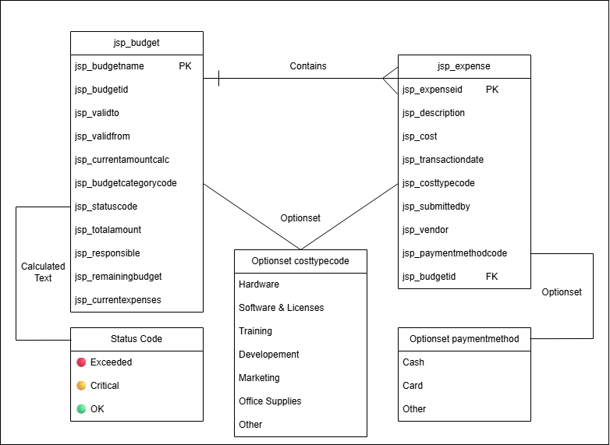

3.3 Test Plan/Cases
To minimize iterations during the Realise phase attempting to adhering to the structured and strict nature of the IPERKA methodology, I decided to define the test cases before starting with development. This allowed me to focus on test/result driven development to give me clear goals to strive for in my functions. This ensured that development was focused solely on passing these pre-defined checks, reducing the risk of scope creep or missing logic.
The testing strategy relies on a manual execution of end-to-end scenarios. These tests were designed to easily be performed one after another, starting from budget creation to expense recording and final reporting.

3.4 UML Diagrams
The time estimation I made for the creation of the UML diagrams proved to be more accurate than most of the estimations for previous tasks. For these diagrams in particular I used draw.io. Similarly to the ERM, making these diagrams was very useful in that it helped me internalise the structure that I was going to have to build later on during the realisation step, enabling a clear understanding of its dependencies before development began.
A specific design decision involved the Weekly Report workflow. While Generating and Receiving the report are technically part of the same logical flow, I decided to model them as two unique Use Cases. This decision was made to keep it clear that these were 2 separate actions, explicitly separating the active role of Power Automate from the passive role of the recipient.

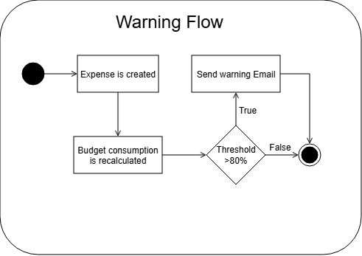
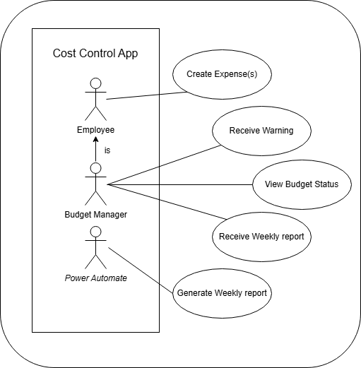

4 Decide
In this phase, I would make decisions on every aspect of my planning thusfar, what to use for which task and what technologies would be best suited for the job. This is also often the shortest phase of projects following IPERKA.

4.1 Architecture & Design Decisions
A fundamental decision was choosing between Custom Plugins (Pro-Code) and Native Dataverse Logic (Low-Code). While plugins offer maximum flexibility and control, they introduce significant maintenance overhead and require complex deployment pipelines. Since the mathematical requirements for this project—such as calculating remaining budgets or percentages—were simple arithmetic, I decided to utilize Native Dataverse Logic, specifically Calculated Fields. This approach provides a robust solution without the technical debt associated with custom scripts.

4.2 Column Strategy
For calculating the total expenses per budget, I evaluated two options: Formula Columns and Rollup Fields. Formula Columns offer the advantage of real-time calculation; however, they calculate values on read. Which as I understand it is similar to a view, which I have personal experience with. I also know that views can take multiple minutes just to load before showing any data. This means that opening a view with thousands of budget records would trigger a massive calculation load, leading to significant performance loss. Therefore, I decided to use Rollup Fields. Although they update asynchronously (every 12 hours), they store the value physically in the database, allowing views to load instantly. I prioritized system scalability over immediate convenience, mitigating the update delay by forcing recalculations via Power Automate when necessary. These fields can I also be manually updated whenever needed

4.3 Visual Indicators
To implement the "Traffic Light" status system, I considered using JavaScript Web Resources to manipulate the form's DOM. This method only changes visuals on the main form, leaving the list views unformatted. After consulting with Loris, I had found out it only needed to show up in the view and not the main form. Instead, I decided to use a Calculated Choice Column with native color coding. This stores the visual status without the need for a plugin and renders consistently across all Forms, Views, and Dashboards.

4.4 Reporting Format
For the Weekly Cost Overview, I had to choose between generating an Excel attachment or embedding an Inline HTML Table. While Excel allows for further data analysis, it requires the user to download and open a file, making it difficult just to see them in the first place. I decided to implement the Inline HTML Table to ensure the report is immediately readable on both desktop and mobile devices. Making it easier for everybody to review budgets.
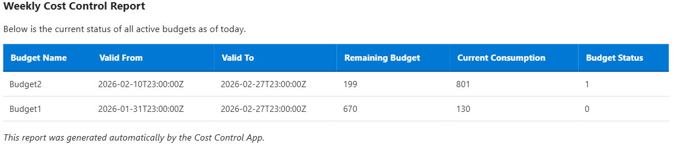

4.5 Date decisions
Another decision I had to make was how to handle budgets and expenses set in both the future and the past. On the one hand, I could have allowed budgets and expenses to be set only to the current day or in the future. If they were set in the future, the question was whether they should be deactivated or treated like the rest.
I ended up choosing the unrestrained route, allowing budgets and expenses to start or end whenever necessary. I chose this partly for myself and partly out of consideration for budget managers. I could test the system by setting expiration dates in the past, and managers could create past budgets that were not entered at the time of their creation. The same applies to expenses.
Future expenses should also be counted toward budgets, even if the transaction has not yet occurred, in order to avoid surprises later on. Using this logic I also decided to allow expenses to be assigned to expired budgets as it is possible that an expense was missed in the past and must be rectified.

4.6 Deactivation of Budget
The last decision I had to make was regarding how budgets would be deactivated. I could, on the one hand, implement a Cascading Deactivation, where setting a Budget to Inactive would also systematically deactivate all related Expense records. This would ensure a clean slate but would effectively hide historical data from standard views.
On the other hand, I could simply deactivate the Budget Record itself while leaving the historical Expense records untouched. I decided to strictly deactivate only the Budget Record.
Expenses are historical financial facts that occurred in the past. Even if a budget is closed, the expenses incurred during its active period should remain Active and accessible. Therefore, the flow only targets the parent Budget entity, preventing new associations while preserving past transactions.

5 Realise
In this phase, the conceptual designs from the planning stage were made into a fully functional solution on the Microsoft Power Platform. My primary focus was to translate the theoretical data model into a Dataverse table which could be viewed through a model driven app. Then create the flows for full functionality.

5.1 Creation of Dataverse entities
The first step of the implementation phase involved setting up the data structure that would serve as the foundation for the flows and the application. I was tasked with creating two Dataverse entities: Budget and Expense.
The Expense table was straightforward to implement, as it required no special column types such as calculated columns. It was therefore completed relatively quickly. I also added two additional columns — Vendor and Payment Method — to support further sorting, though these were ultimately not used in the final implementation.
Initially, I considered this task trivial. That said, the logic required for Calculated and Rollup Fields was entirely new to me. I soon discovered that Calculated Fields cannot retrieve data from related tables, whereas Rollup Fields are specifically designed to aggregate data across relationships, albeit with limited calculation capabilities.
It is worth noting that the system repeatedly recommended using the newer Formula Columns over legacy fields. After consideration, I concluded that Rollup Fields were the more appropriate choice. Formula Columns evaluate values in real time, which — as I understand it — functions similarly to views in SQL. From personal experience, this approach can lead to performance degradation when processing sufficiently large datasets. I therefore prioritized system performance and scalability over the modern standard recommended by Microsoft.

5.2 Calculated/Rollup Field Configuration
During the implementation of the Dataverse entities, I configured a total of four columns with custom logic, using both Rollup and Calculated field types.
The creation of the Rollup field Current Expenses was straightforward due to its limited calculation capabilities. It simply sums all costs from the related Expense records.
In contrast, the Calculated fields required a more creative approach. I created a prior to the step, unplanned field, Warning Threshold. Its logic is very simple, being the Total Budget times 0.8. It is used once as the trigger condition for the Warning Flow but also as a column for the next field, Budget Status.
For Budget status, I created logic to automatically switch between OK at 0-79%, Warning 80-99%, and Exceeded 100% and above, based on the percentage of the budget used at that point.
To fulfill the optional requirement for visuals, I used the color coding feature of the Choice column. Implementing this required locating and navigating the legacy Classic Editor, as this feature is not available in the modern Power Apps Designer. This took some time to find.
The remaining two calculated fields, Remaining Budget and Warning Threshold, were implemented without complications. They are based on simple arithmetic calculations using the existing budget and expense values.

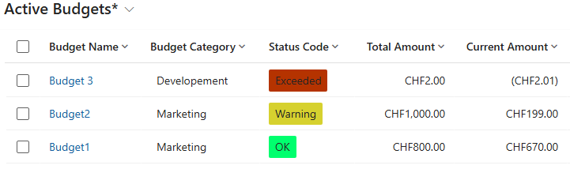

5.3 Flows
To implement the required business logic and reporting requirements, I developed three distinct Power Automate Cloud Flows. These were all created in the same Practise IPA Solution as the rest of my project. These flows are responsible for the logic of all nonstandard functions I was tasked with creating, such as a warning message when approaching a budget limit, one which deactivates expired budgets. And an overview of all budgets which is sent weekly.
The Warning Flow serves as a real-time monitoring tool. It triggers immediately upon the creation of a new expense to verify if the budget limit has been exceeded and alerts the responsible user if necessary.
The Deactivation Flow acts as a scheduled maintenance task. It runs daily to identify budgets that have passed their “Valid To” date and automatically sets their status to Inactive.
The Weekly Overview Flow handles the reporting requirement. This scheduled flow runs once a week and collects data from all active budgets, formats it into an HTML table, sends an email containing the relevant information for all active budgets.

All of these flows were created using a try, catch, finally structure. Due to the flows simplicity this was overkill, however it is required by the guidelines and was implemented, nevertheless. The try block runs after the trigger and contains the bulk of the function, the catch scope contains the error handling and runs only if the try block failed for any reason. The Finally block always runs but contains nothing in any of the 3 previously mentioned flows.
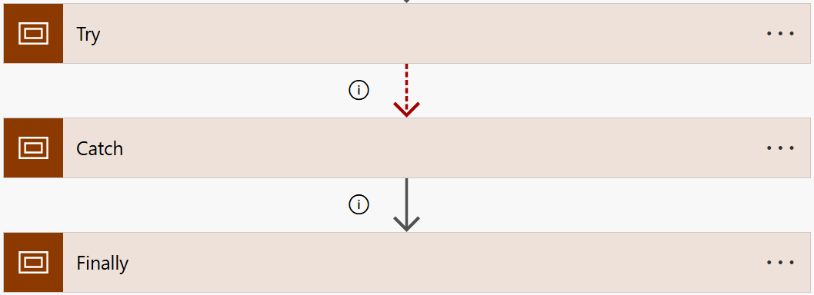

5.3.1 Warning flow
The first flow I created was the warning flow; the reasoning behind this decision is discussed in a separate chapter. This flow was by far the most complex, combining Dataverse actions, HTTP requests, and conditional logic to handle the email sending process.
A significant technical challenge was retrieving the current total consumption that is, the sum of all expenses. Since the Rollup Field jsp_currentexpensescalc is calculated asynchronously on a 12-hour cycle, its value could not be relied upon to trigger warnings accurately. To resolve this, I added two actions: first, a Get Row step to retrieve the related Budget entry, followed by an HTTP GET request which uses the CalculateRollupField endpoint, which makes Dynamics recalculate the specified field for the given record.

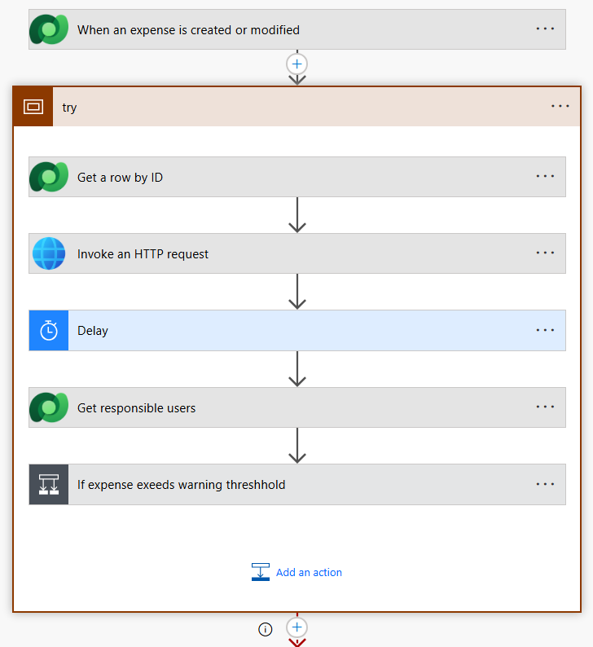

For the notification, I used the default Outlook 365 Connector. The email body is constructed dynamically, pulling the Budget Name, the calculated Total, and a direct link (URL) to the record in the Model Driven App. And to decide whether or not to send the email simply recreated the same logic found in the calculated field of the status optionset. That being to see if the current consumption was equal to or above the budgets warning limit which is 80% of the total budget value. If that is true it checks if the total budget is being exceeded by the current expense value and sends a normal warning or critical warning respectively.

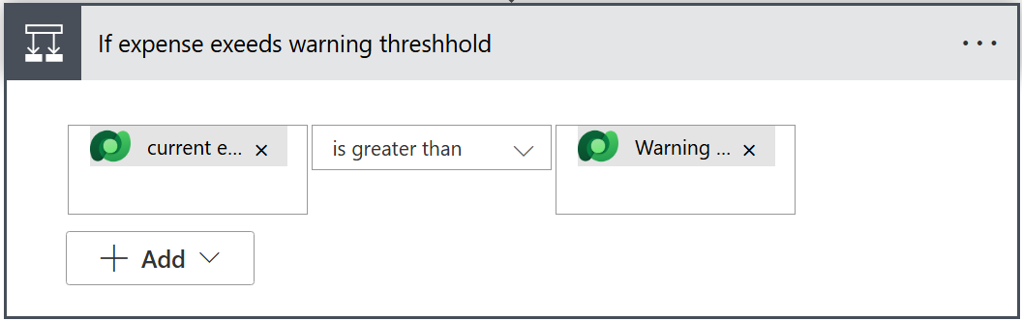
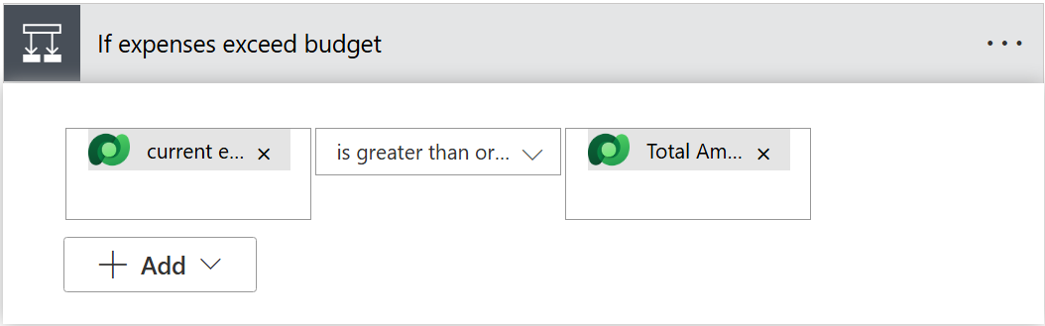
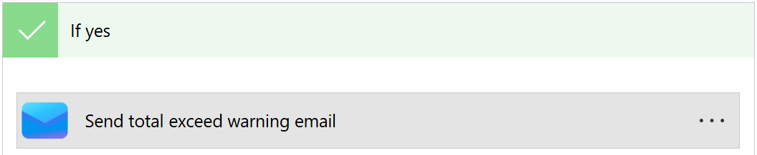
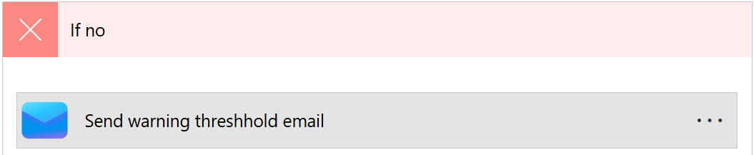

5.3.2 Deactivate expired budgets flow
Creating this flow was very straightforward, running once a day to check which budgets had expired the day before by comparing the ValidTo date with 00:00 of the day the flow runs. It lists only the budgets that meet the criteria and deactivates them one by one using an Apply to each loop seen in the screenshot below.
I did run into a slight issue when trying to use the utcNow function inside the OData filter, which did not work. Instead, I composed the value in a prior step rather than creating an additional condition and retrieving more budgets than necessary, which would negatively affect performance, even though I currently only have three entries.

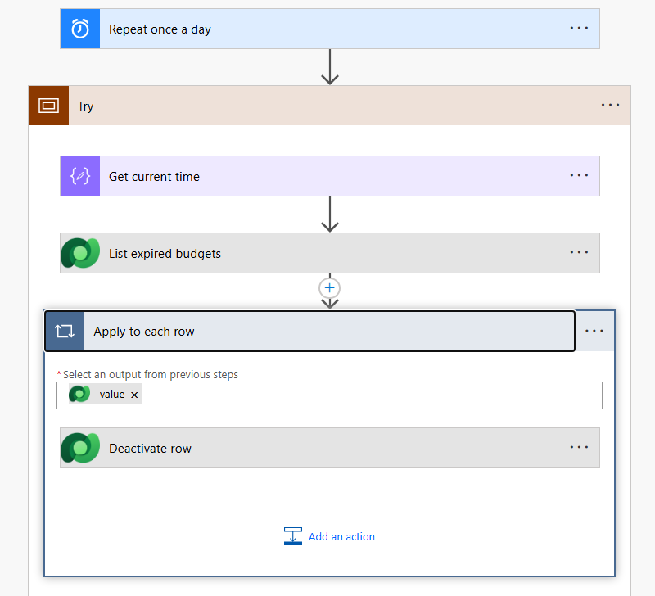

5.3.3 Weekly Cost Overview flow
The Weekly Cost Overview flow was quite complex to build, even though on the surface it seemed very simple: retrieve all budgets and send an email. Creating the formatting and even sending the email came with several challenges.
As the name implies, this flow runs once a week, in this case on Monday morning. It retrieves all rows from the Budget table, creates a formatted table using the Select data operation, and then converts it into HTML using the Create HTML table operation.
The final step, sending the email, caused issues. When using Send an Email V3, Dynamics blocked the flow from sending emails for an unknown reason. I switched to V2 instead and plan to test the email functionality again. If this also fails, I will switch to a simple Teams notification.
The email formatting took quite some time, as it had to be written in HTML for optimal results. Since I am not very familiar with HTML, I asked Gemini for help with styling the email.

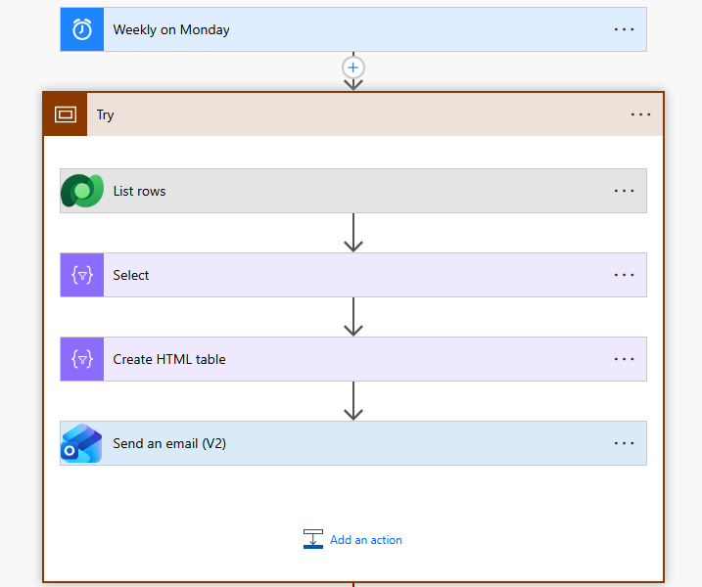

5.4 Questions
During development asking questions was much easier than during the phases prior as Loris was around and ready to help. I asked him multiple questions regarding the nature of some tasks and the feasibility of other such as the possibility of colored backgrounds for fields in forms. This was regarding the optional task of traffic light visualisation. He responded saying that it was possible to implement color coded backgrounds in views but was not conceivable in forms. I also asked about auto updating rollup fields, as I had one issue where the warning flow would run before the field it was controlling was updated. I later figured out how to implement the logic through an http request.

6 Control

6.1 Test Protocol
The primary objective of the testing phase was to verify that the solution meets all functional requirements as defined in the Inform phase. The scope included end to end testing of the Dataverse entities, the three Power Automate flows, and the user interface of the Model Driven App.

Scope of Testing:
- Functional Verification: Ensuring Budgets and Expenses can be created, linked, and calculated correctly.
- Automation Validation: Verifying that the Warning, Deactivation, and Reporting flows trigger under the correct conditions.
- Boundary Testing: Checking behavior at critical thresholds such as exactly 80 percent or 100 percent budget usage.
- Error Handling: Validating that the system rejects invalid inputs such as negative amounts or missing required fields.
Out of Scope: Due to the limited time frame of the project, performance and stress testing with large datasets such as more than 10,000 records, as well as security role testing since no custom roles were defined, were excluded from this test plan. All tests were conducted in the development environment using the account josiah.spilker@godiz.com.
Test Environment:
- Tester: Josiah Spilker
- Date: 24.02.2026 – 25.02.2026
- Browser: Firefox (latest)
- Environment: Josiah’s Environment (DEV)
- T-12 Was tested in Leandro’s Environment (DEV)

6.2 Test Case T-08
During the initial test T 08, it was possible to enter a negative expense amount such as minus 50.00 CHF, which caused the Rollup calculation to incorrectly increase the remaining budget.
Error Behaviour: The system accepted minus 50.00 and the Rollup calculation simply subtracted it, effectively adding money back to the budget. This is not desired behaviour for this iteration. To fix this, I changed the minimum amount from minus 922’337’203’685’477 to 0.

Retest T 08 Result:
The system now prevents the user from saving the record. The error is caught at the interface level.
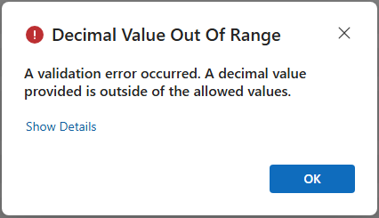

6.3 Test Case T-12

During the deployment of the Managed Solution into the target environment Leandro’s Environment, the import process failed to validate the connections for the Warning Flow.
Error:
The solution import wizard flagged the HTTP with Microsoft Entra ID connection as invalid. Unlike standard Dataverse connectors, this specific connection requires a hardcoded Base Resource URI which is the environment URL and an Application Client ID during connection creation. Since the flow was built using a connection specific to my Development Environment, the connector refused to authenticate in the new target environment without manual reconfiguration of the URI. Furthermore, my user did not have the necessary application permissions in Leandro’s environment to authorize this specific HTTP request.
Impact:
The Warning Flow could not be activated immediately upon import. The solution installed successfully, but the flow remained in an unusable state.
Mitigation:
This issue highlights a limitation in the current architecture. The HTTP with Microsoft Entra ID connector is environment specific and not easily portable in a basic Managed Solution without using environment variables or a custom connector.
As a workaround for this test, I had to:
- Manually create a new Connection in the target environment using Leandro's Environment URL.
- Update the flow (using an unmanaged layer) to use this new connection.
Conclusion: For a production rollout, this architecture would need to be revised to use environment variables for the Base URI to ensure seamless deployment across different environments.

6.3 Boundary Testing
This section focuses on the exact thresholds of the business logic to ensure the transition between statuses OK, Warning, and Exceeded happens at the mathematically correct moment.

Test Protocol: Boundary Values
Test Environment:
- Tester: Josiah Spilker
- Date: 24.02.2026 – 25.02.2026
- Browser: Firefox (latest)
- Environment: Josiah’s Environment (DEV)

The goal was to verify whether the warning trigger is inclusive or exclusive. The requirement I set for myself at the start of the project was that the warning should display when the budget exceeded or was exactly 80 percent. Not earlier. The same logic applies to exceeding the total budget value defined at creation.
Procedure
- Created a Budget of 100.00 CHF for simple calculation.
- Added an expense of 79.95 CHF.
- Checked the Status.
- Modified the expense to 80.00 CHF exactly.
- Checked the Status.
Expected Result: At 79.95 CHF: Status OK, at 80.00 CHF: Status Warning.
Result: At 79.95 CHF: The system displayed OK, 80.00 CHF: The system displayed Warning.
Conclusion: This is exactly what I had planned the function to do, and it worked without problems. One consideration during testing was the base values, which are filled using a fixed currency in this case Swiss francs. This was outside the defined scope, as the task description did not mention foreign currencies. In a production project, it would make sense to test currency related scenarios as well.

6.4 Concurrency Scenario
Another aspect that required testing was whether the Warning Flow behaves correctly when expenses are added in quick succession. This simulates a scenario where multiple managers add expenses to the same budget simultaneously. A potential issue could be the Warning Flow using an outdated value during its calculation.
Procedure
- Setup: Create a Budget of 1,000.00 CHF with no expenses.
- Action: Open two browser windows both logged in to the same environment.
- Execution:
  - In Window A: Prepare an Expense of 850.00 CHF.
  - In Window B: Prepare an Expense of 200.00 CHF.
  - Simultaneously click "Save" in both windows (within a couple seconds of each other).
Expected Result: Both expenses are saved. The calculated total consumption should read 1,050.00 CHF and the Warning Flow should trigger. The flow should detect that the combined total of 1,050 CHF exceeds the budget and send the Exceeded alert, not just the Warning alert.
Result: Both records were saved successfully. Two separate flow runs were triggered.
Run 1 detected both expenses and sent the exceeded email because the HTTP CalculateRollupField request fetched both expenses.
Run 2, executed seconds later, correctly retrieved the total of 1,050 CHF using the same HTTP CalculateRollupField request.
Notification: The responsible manager received the Exceeded notification twice instead of receiving one Warning and one Exceeded notification.
Conclusion: This is not exactly the intended behaviour, as the manager should receive accurate information relevant to the specific point in time. In this scenario, the only inconvenience is the manager receiving two nearly identical emails. A potential fix would involve checking the previous total expense before running the flow. However, this approach resulted in emails being sent only under very specific conditions and did not properly support reductions or corrections of expenses.

7 Evaluate
The final phase of the project is dedicated to an assessment of the implemented solution and the development process itself. In this chapter, I compare the final product against the requirements that I defined in the Inform phase and before, to determine my degree of my success, before it’s determined by someone else. I also intend to reflect on my personal performance, analysing the accuracy of my time planning, the effectiveness of my decisions and what went wrong with those that didn’t pan out, and the lessons learned for future projects. This evaluation provides a view of both the technical outcome and the project management methodology applied.

7.1 Reflection
Overall, the project was a success. The techniques and skills I developed since joining Godiz could be applied effectively within a single, coherent project. The implementation phase was productive, as was the creation, modification, and continuous updating of the Gantt chart.
A detailed reflection on the project methodology is provided in the following subchapter. Beyond that, the work progressed smoothly outside of the IPERKA framework. The documentation was straightforward to complete, with only minor formatting issues arising throughout the process.
In terms of planning, the duration of most tasks was significantly overestimated. Future projects would benefit from more granular planning while avoiding overly rigid time estimates. The Gantt chart also proved difficult to integrate into the documentation due to its scope and the inclusion of features not directly relevant to the target/actual comparison. In addition, a number of planned steps required adjustments during implementation, resulting in noticeable differences between the initial plan and the final execution.
For the real IPA, required tasks should be prioritized over optional ones. In the case of this practice IPA, the project scope was relatively small, and all tasks were completed ahead of schedule. A results-driven, test-based development approach proved effective throughout the project.
The required diagrams, such as UML and ERM, served to document conceptual understanding of the project. In practice, however, they were of limited value during development and were not referenced again after their initial creation. Greater opportunity for requirements clarification would have been beneficial, as ambiguity in certain areas led to development decisions that ideally should have been defined more precisely during the task specification phase.

7.2 IPERKA concerns
During the Realisation phase, I developed a deeper understanding of the IPERKA model. I found this phase particularly challenging to execute in a strict and linear manner. On several occasions, I strayed from previously planned decisions. Rather than restarting the entire Inform, Plan, and Decide cycle for each adjustment, I acknowledged the deviation and proceeded.
Regarding the Gantt chart, I initially included tasks that later proved To solve this. My first instinct was to remove them. That said, on Friday, David conducted a simulated expert review and advised that such discrepancies should remain in the documentation and be justified, rather than deleted. This showed me the importance of transparency in the planning process. However, this feedback came after my deletions, and the changes had been cemented. These tasks were Concept approval which was the second step in planning. Another was an implement visuals task at the end of realise, with that in mind this was scrapped and simply worked on during T4.1-T4.3 along with the other elements of the project.
Another challenge was the distinction between planned and actual work. Separating tasks clearly on paper does not always reflect the reality of development. For example, I spent five hours completing what appeared to be three separate tasks in the plan, while in practice I was working simultaneously on a single Flow and its related entities.
Real world IT development rarely follows a strictly linear and rigid structure. While IPERKA and similar waterfall oriented models provide a useful framework, they over-simplify software development. In practice, requirements change and evolve, technical challenges arise, and decisions often need to be revisited.
For this reason, iterative and agile approaches often reflect practice more accurately. They allow for adjustments during development rather than treating changes from the original plan as exceptions. Despite this, structured models like IPERKA still serve an important purpose in education, as they help to develop skills such as planning reflection and the importance of structure.
In that sense, the limitation is not that IPERKA is flawed, but that it represents an idealized process that prioritizes clarity and structure over adaptability.

7.3 Possible Future Improvement
During the development of this project, I found several missed opportunities and partially developed ideas, some of which would be worthwhile to implement in the future. A notable one was the absence of security roles. In a realistic budgeting system, role based access control would be essential. For example, only managers should be able to create and modify budgets, while employees would have read access to budgets, they do not manage themselves. All users could be permitted to create and manage expenses and assign them to budgets.
Another potential enhancement would be the introduction of an expense approval workflow. Expenses could require approval by a designated internal reviewer before being applied to a budget, preventing unrestricted or excessive submissions.
There were also features that I did not fully implement. One example is the deployment fix related to the warning Flow. When deploying to another environment, the Flow contains a hard coded address that must be adjusted after migration. If this is not handled correctly when importing as a managed solution, the entire deployment process must be repeated.
Additionally, the current logic allows repeated warning emails to be sent if further expenses are added to a budget that has already exceeded its limit. This could result in unnecessary notification spam to managers and should be refined.
Another flow with potential for improvement is the Weekly Budget Overview. Currently, it sends emails to a hardcoded list of recipients in this case, only me. A different approach would be to retrieve every System User assigned the Manager security role (assuming this were implemented). However, creating this would require a complex query due to the (n:n) relationship between Users and Roles.
Finally, multicurrency handling was neither specified in the task description nor considered during development and testing. In a real world budgeting system, however, support for multiple currencies would likely be a requirement.

7.4 Summary

godiz ag uses an internal Microsoft Dynamics 365 CRM system for organisational and administrative purposes. Prior to this project, no integrated solution existed for tracking operational costs or monitoring budgets within the system. Expenses were recorded and managed manually, resulting in a lack of transparency over budget consumption and no automated mechanism to detect overruns.
Solution
A low code Cost Control Component was designed and implemented entirely on the Microsoft Power Platform within a single Dataverse solution. The solution introduces two custom entities Budget and Expense with a one-to-many relationship. Calculated and rollup fields automate the calculation of current consumption, warning thresholds, and budget status. A colour-coded status indicator green / yellow / red provides immediate visual feedback directly within the Model Driven App. Three Power Automate Cloud Flows handle automated warning notifications upon threshold breach, daily deactivation of expired budgets, and a weekly email overview of all active budgets. The solution was packaged as a Managed Solution, enabling deployment into new environments.
Results
All required functional and non-functional requirements were met. 25 test cases were executed, covering standard functionality, boundary values, error handling, and a concurrency scenario. One defect was identified and resolved during testing the system previously accepted negative expense amounts, which has since been corrected through modification of the column. A deployment consideration regarding an environment-specific HTTP connector was noticed and documented. As this connector requires an environment specific URI and user login, it must be correctly configured during the solution import process.
Conclusion
The implemented Cost Control Component provides godiz ag with a transparent, automated solution for budget monitoring within Dynamics. It is recommended that future iterations address the hard coded connector limitation to ensure seamless cross-environment deployment and consider extending the solution with an expense approval workflow and multi-currency support.

8 Appendix

8.1 Glossary
CRM:
is a software platform used to manage and track Data and can be used by clients through user interfaces such as model driven apps. It uses a built in data storage system called Dataverse.

Dataverse:
A cloud-based, low-code data platform provided by Microsoft. It allows for the secure storage and management of data used by business applications. It serves as the relational database backbone for the Model Driven App in this project.

Entity & Table:
In the context of Dataverse and this project, an entity or table is a type of data record, similar to a table in a relational database. Entities in this project are Budget and Expense.

ERM (Entity Relationship Model):
A graphical representation of data structures that illustrates the relationships between different entities. It was used in the planning phase to design the database architecture.

Flow:
An automated workflow created in Microsoft Power Automate. Cloud Flows are used in this project to handle logic such as sending warning emails, deactivating records, and generating reports.

HTTP Request:
An online request used to communicate between a client and a server. In this project, an HTTP request is used within a Flow to force the immediate recalculation of a Rollup Field.

IPERKA:
A project management method standard in Swiss vocational training. The acronym stands for Inform (Informieren), Plan (Plannen), Decide (Entscheiden), Realise (Realisieren), Control (Kontrollieren), and Evaluate (Auswerten).
Managed Solution:
A solution package in the Power Platform intended for distribution to other environments. Components in a managed solution are locked and cannot be directly modified in the target environment, ensuring deployment integrity.

Model Driven App:
A type of Power App where the component design and layout are determined by the underlying data structure (Dataverse) and relationships, rather than by pixel-perfect drag-and-drop design.

OData (Open Data Protocol):
A standard protocol for querying and updating data. It is used in Power Automates List rows and Filter query actions to efficiently retrieve specific records from Dataverse.

Rollup Field:
A column type in Dataverse that calculates data from related child records using number operations such as Sum, Count, Max, Min. Unlike Calculated Fields, they typically calculate every 12 hours unless forced.

URI (Uniform Resource Identifier):
A unique sequence of characters that identifies a logical or physical resource. In this project, the Base Resource URI is required to authenticate the HTTP connection to the specific Dynamics 365 environment.

8.2 Bibliography
Gantt Template:
Microsoft Excel Templates: Gantt Chart – 16.02.2026

Auto update rollup help:
How To Automatically Calculate a Rollup Column with Power Automate – 20.02.2026

Gemini (AI Assistance):
https://gemini.google.com – 16.02.2026 – 25.02.2026

8.3 Declaration of Independent Work
I, Josiah Spilker hereby declare that this work is entirely my own and that outside assistance is declared where used.

